ARRAY

**EX1**. Write a program that accepts 10 integers from the user and prints the sum of these 10 numbers on the screen.

For example, if you enter the following numbers:



When the code is compiled and executed, it produces the following result:



**EX2**. Write a program that accepts an array arr of n integers from the user and prints the largest element in the array.

For example, if n = 5, arr = [2, 7, 6, 8, 9], enter the values as below:

5 
2 7 6 8 9 

When the code is compiled and executed, it produces the following result:



**EX3**. Write a program that accepts an array arr of n integers and prints the sum of the first element and the last element in arr on the screen.

For example, if n = 5, arr = [2, 7, 6, 8, 9], enter the following values:

5 
2 7 6 8 9 

When the code is compiled and executed, it produces the following result:



**EX4**. Write that accepts an array arr of n integers from the user and prints all even numbers in arr on the screen.

For example, if you enter the following values:

5 
2 7 6 8 9 

The code will produce the following result:

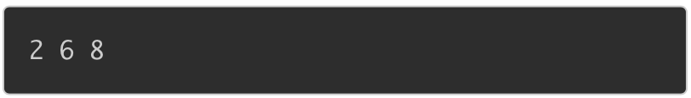

**EX5**. Given an array arr of n integers and an integer k. Write a program that accepts these variables from the user and prints the number of elements in arr, which are equal to k.

For example, if n = 6, arr = [3, 8, 7, 8, 3, 3], k = 3, enter the following values:

6 
3 8 7 8 3 3 
3 

When the code is compiled and executed, it produces the following result:



**EX6**. Given an array arr of n integers. Write a program to return the sum of odd numbers in arr, which are greater than 0.

For example, if you enter the following values:

8 
3 -7 2 59 -6 10 12 

The code will produce the following result:



Because 3 + 5 + 9 = 17

**EX7**. Given an array arr of n integers. Write a program that accepts array arr and displays all numbers in arr, which are greater than or equal to 0 and less than or equal to 10.

For example, if you enter the following values:

8 
3 -7 2 59 -6 10 12 

When the code is compiled and executed, it produces the following result:

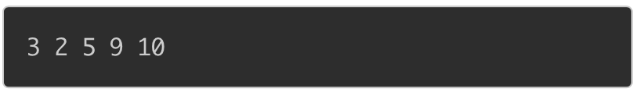

**EX8**. Given an array arr of n elements. Write a program to sort all elements in ascending order and print the sorted array on the screen.

For example, if n = 6, arr = [5,3,2,6,7,7], enter the following values:

6 
5 3 26 7 7 

When the code is compiled and executed, it produces the following result:



**EX9**. Write a program in C to copy the elements of one array into another array.

-----

***Test Data*** :

Input the number of elements to be stored in the array :3

Input 3 elements in the array :

element - 0 : 15

element - 1 : 10

element - 2 : 12

-----

***Expected Output*** :

The elements stored in the first array are :

15 10 12

The elements copied into the second array are :

15 10 12

--------------------------------------------------------------------------------------------------

**Explain**:

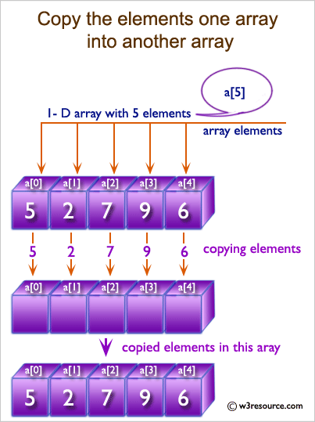

**EX11**. Write a program in C to merge two arrays of same size sorted in decending order.

-----

***Test Data*** :

Input the number of elements to be stored in the first array :3

Input 3 elements in the array :

element - 0 : 1

element - 1 : 2

element - 2 : 3

Input the number of elements to be stored in the second array :3

Input 3 elements in the array :

element - 0 : 1

element - 1 : 2

element - 2 : 3

-----

***Expected Output*** :

The merged array in decending order is :

3 3 2 2 1 1

--------------------------------------------------------------------------------------------------

**Explain**:

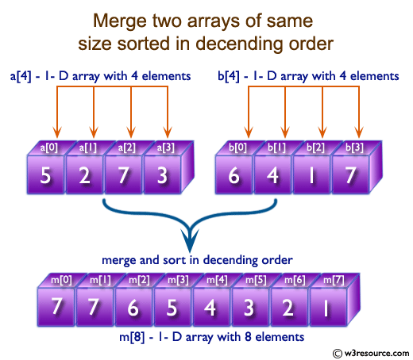

**EX11**. Write a program in C to count a total number of duplicate elements in an array.

-----

***Test Data:***

Input the number of elements to be stored in the array :3

Input 3 elements in the array :

element - 0 : 5

element - 1 : 1

element - 2 : 1

-----

***Expected Output*** :

Total number of duplicate elements found in the array is : 1

--------------------------------------------------------------------------------------------------

***Explain***:

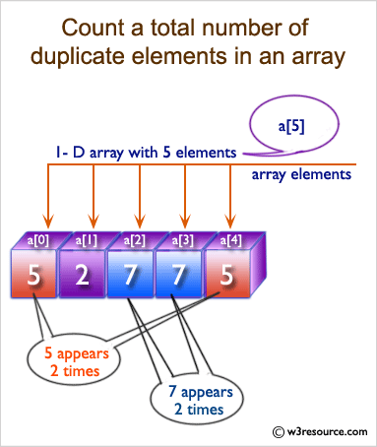

**EX12**. Write a program in C to print all unique elements in an array.

-----

***Test Data***:

Print all unique elements of an array:

------------------------------------------

Input the number of elements to be stored in the array: 4

Input 4 elements in the array :

element - 0 : 3

element - 1 : 2

element - 2 : 2

element - 3 : 5

-----

***Expected Output*** :

The unique elements found in the array are:

3 5

------------------------------------------------------------------------------------------------

**Explain**:

